**The Tableau HR Scorecard: Measuring Success In Talent Management**

1.Introduction

1.1 Over view

The Tableau HR Scorecard is a framework designed to measure and evaluate the success of talent management strategies within an organization. It provides a way for HR professionals and business leaders to track and analyze key performance indicators (KPIs) related to workforce planning, recruitment, retention, and development.

The HR Scorecard consists of four main perspectives:

1. Financial Perspective: This perspective focuses on the financial impact of HR initiatives, such as the cost of recruitment, training and development, compensation and benefits, and turnover.
2. Customer Perspective: This perspective measures the satisfaction of internal and external customers of HR services, including employees, managers, and job candidates. It includes KPIs such as employee engagement, manager satisfaction with HR support, and candidate experience.
3. Internal Process Perspective: This perspective assesses the effectiveness and efficiency of HR processes, such as recruiting, onboarding, performance management, and employee development. It includes KPIs such as time to fill vacancies, time to productivity for new hires, and training hours per employee.
4. Learning and Growth Perspective: This perspective evaluates the organization's investment in employee development and its ability to innovate and adapt to changing business needs. It includes KPIs such as employee skills and competencies, employee retention, and the percentage of employees who receive regular training and development.

1.2.Purpose

The HR scorecard is a strategic HR measurement system that helps to measure, manage, and improve the strategic role of the HR department. The HR scorecard is meant to measure leading HR indicators of business performance. Leading indicators are measurements that predict future business growth.

2.Problem Statement and Design Things

The HR scorecard, or Human Resource Scorecard, is a well-known HR tool. In this article, we will explain what the HR scorecard is, the difference between the HR scorecard and the balanced scorecard, modern-day critique, and show an example template of the HR scorecard.

2.1.Empathy Map

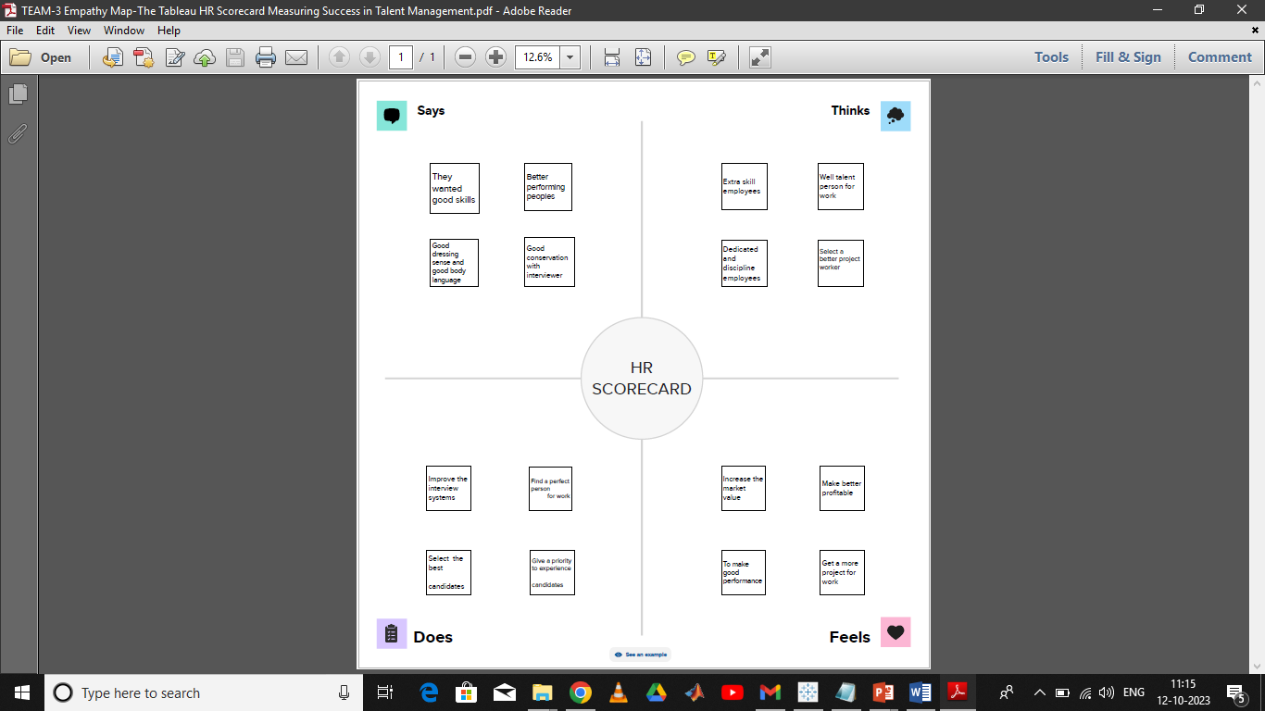

2.2.Ideation and Brain storming Map

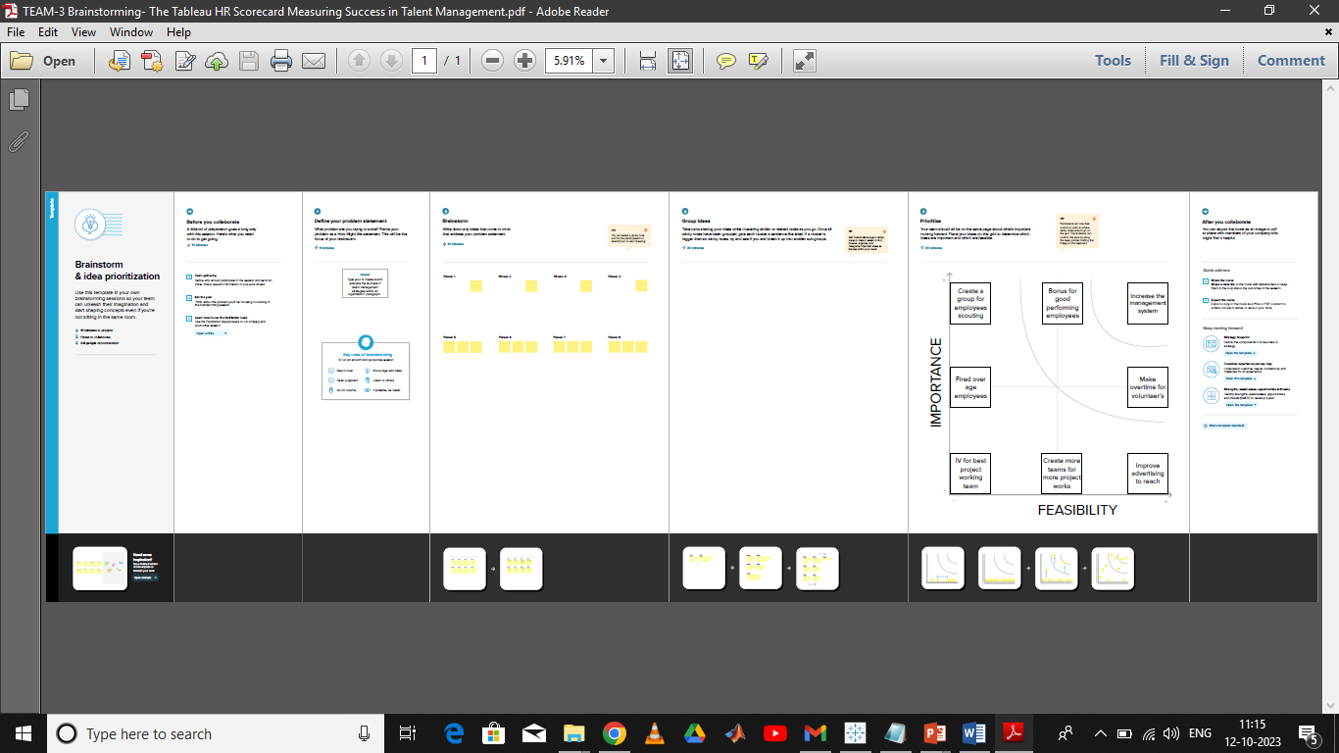

3. Result

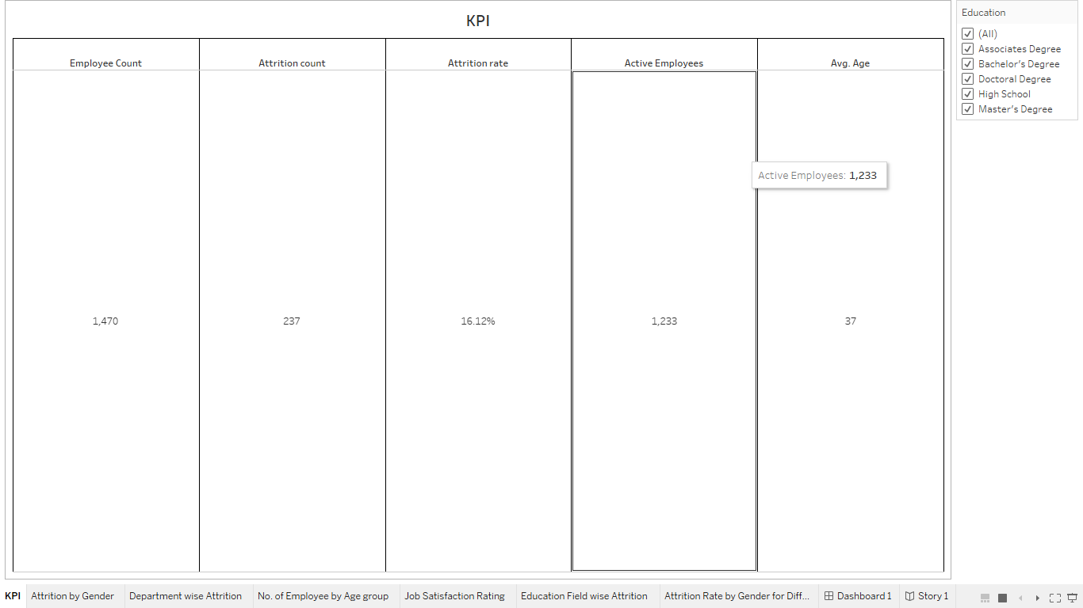

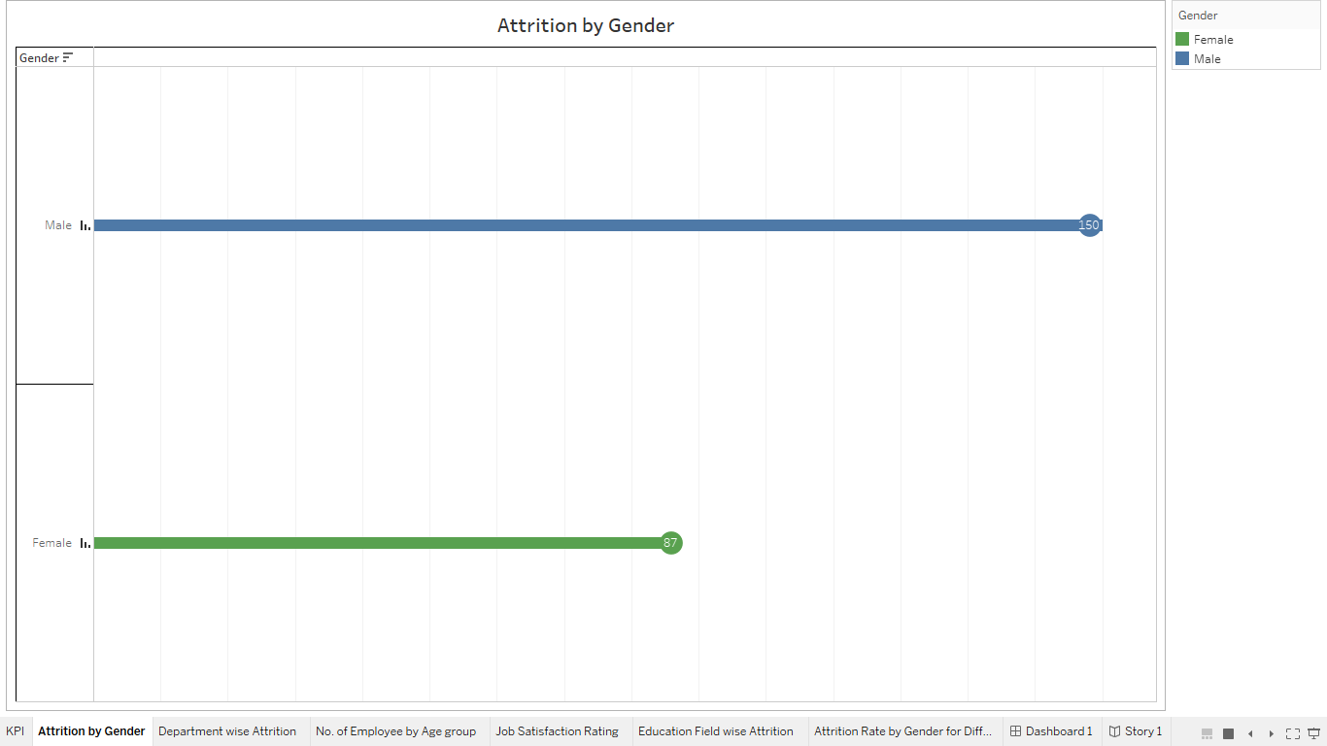

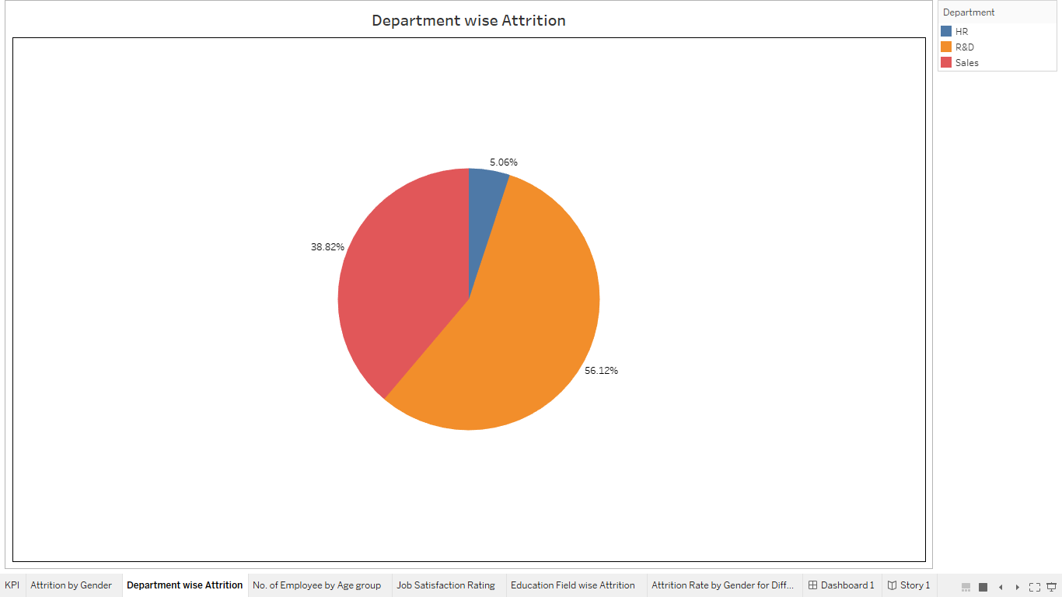

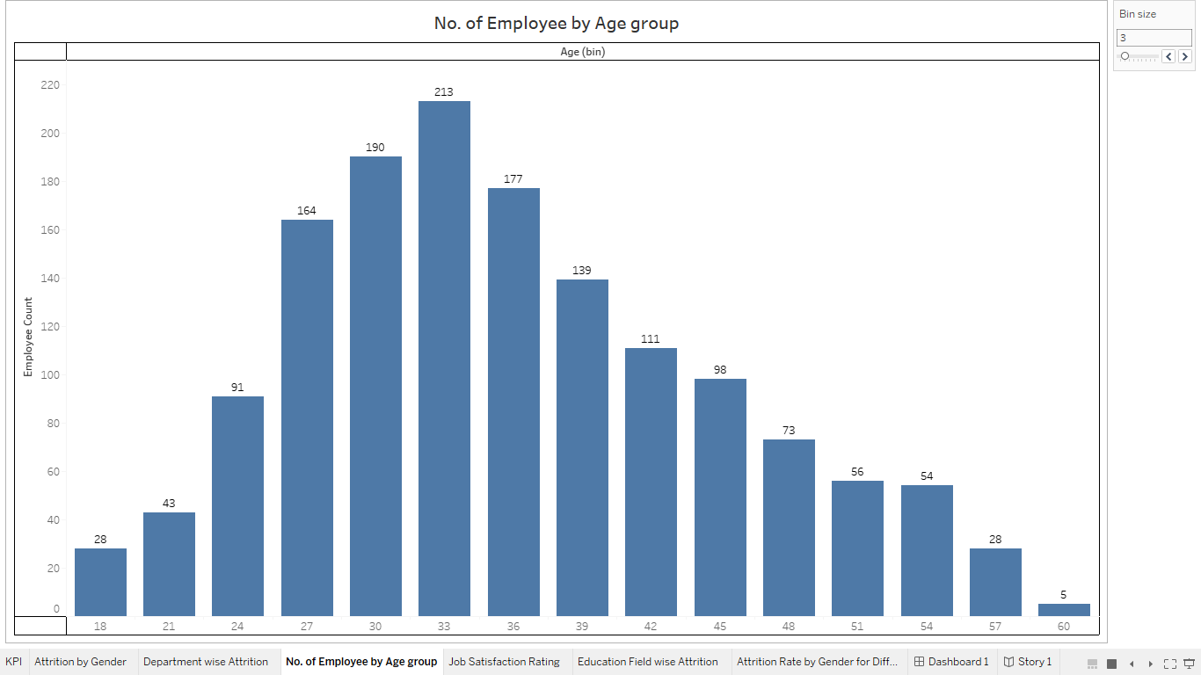

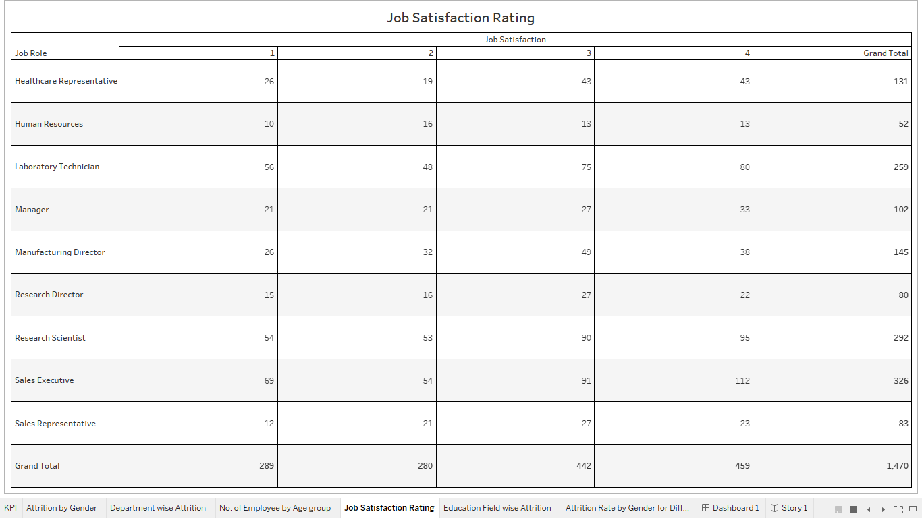

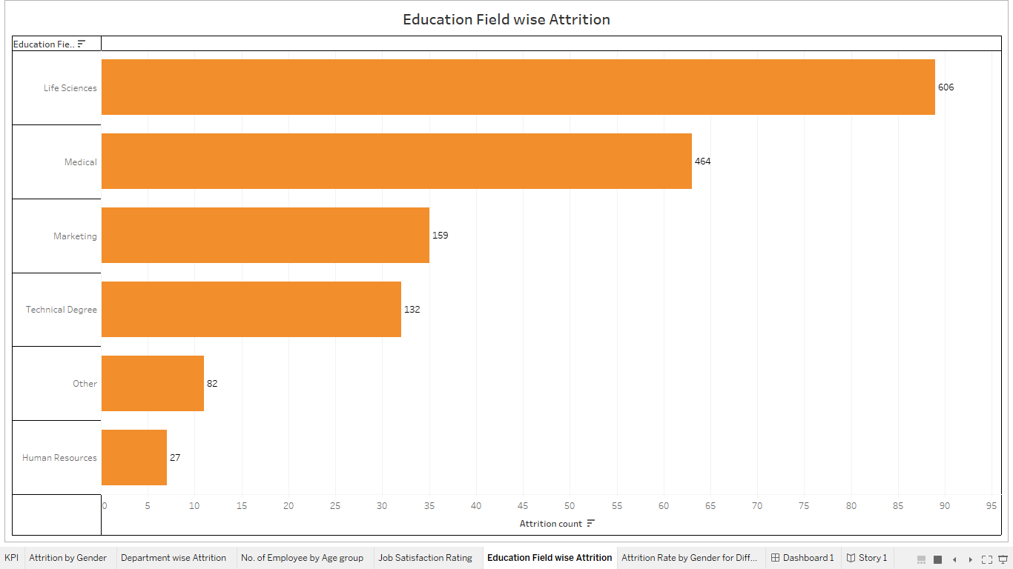

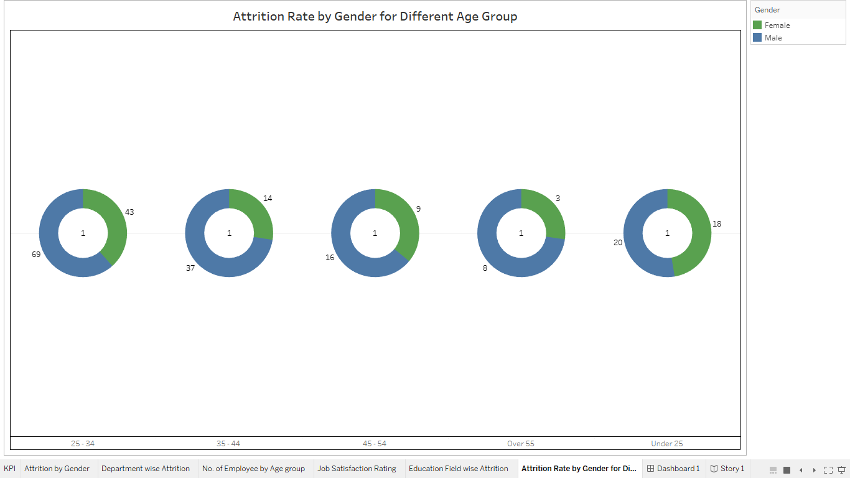

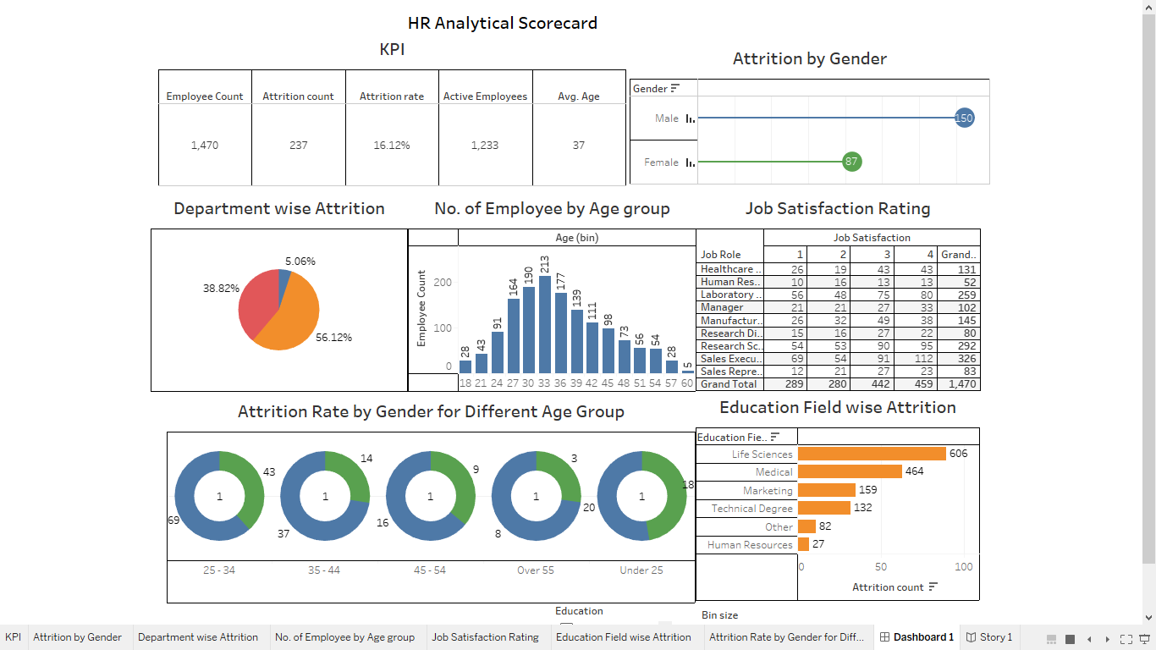

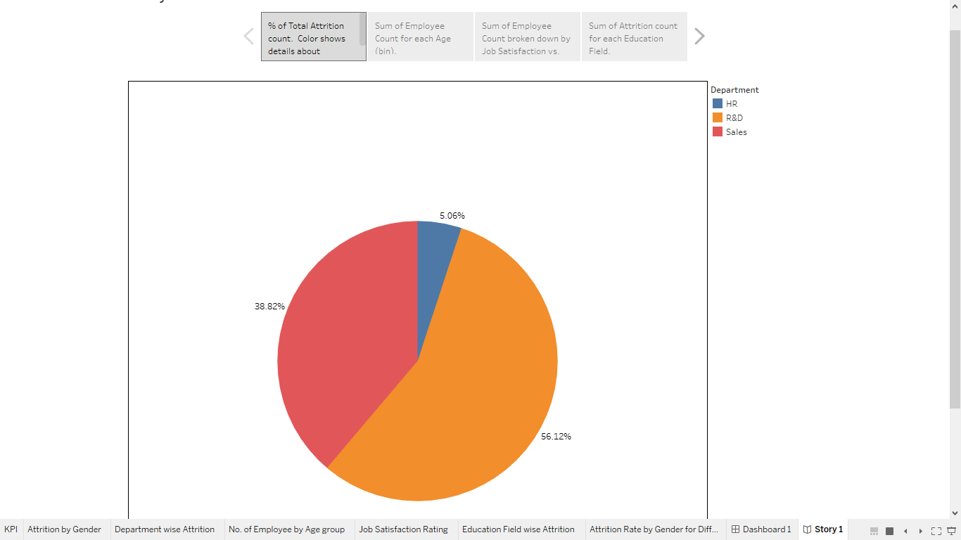

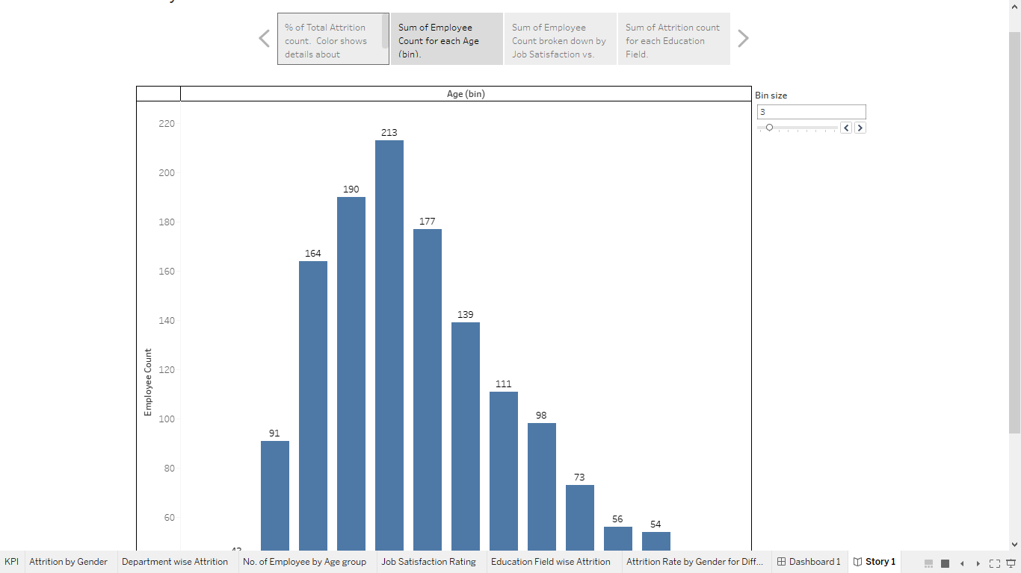

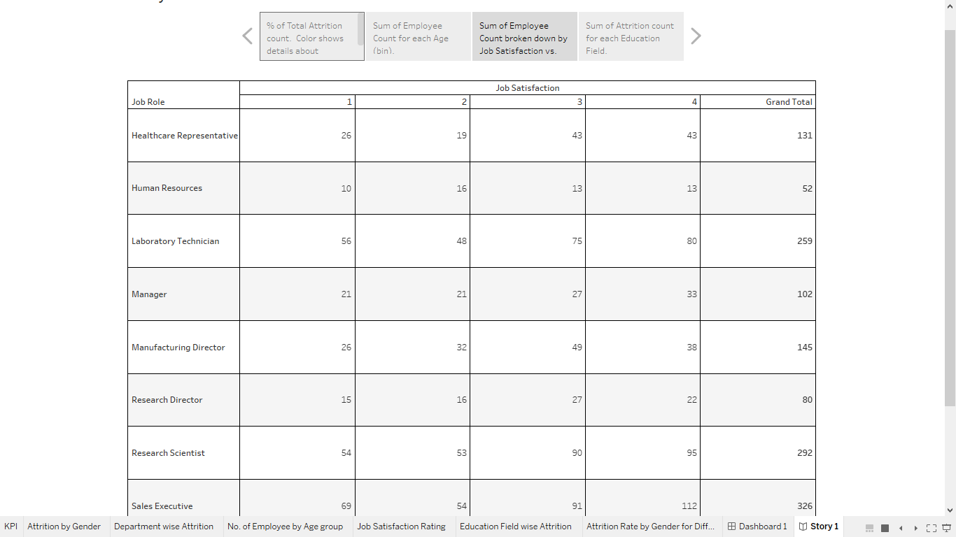

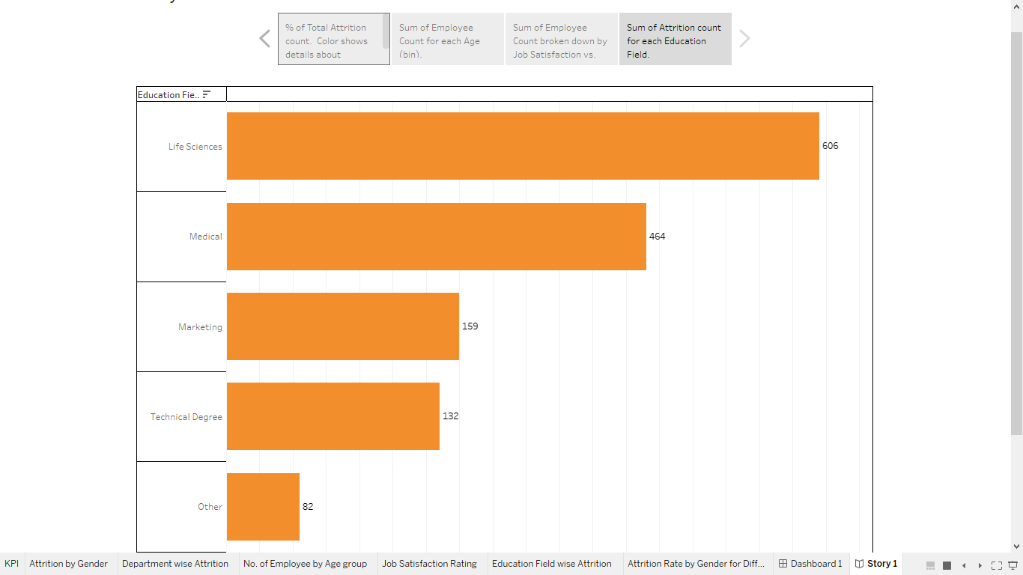

4.Advantages and Disadvantages

Advantages:

* Gives employees clear goals to keep in mind while working on measures.
* Helps employees identify key goals.
* Allows employees to better understand the strategic elements that need work.
* Enables employees to see how objectives affect one another.

Disadvantage:

* The disadvantages that we will discuss, in most cases, are not the disadvantages of the framework but the **downsides related to its specific implementation**.
* A typical misleading idea is that it is all about “balancing” KPIs by placing them into the four perspectives

5.Application

The **HR scorecard** is meant to measure leading **HR** indicators of business performance. Leading indicators are measurements that predict future business growth.

6.Conclution

An HR scorecard helps measure the effectiveness of HR initiatives by using leading indicators, which predict future business growth. These indicators, known as HR deliverables or metrics, are linked to the business strategy and show how well HR efforts contribute to the organization's success.

7.Future Scope

An HR Scorecard is a tool that helps a company use its human resources strategically and prove how HR contributes to financial success. The scorecard measures HR deliverables, metrics, and KPIs that help companies assess and foresee organizational growth and development. The HR Scorecard aligns the company’s strategies with efficient goal achievement metrics. It guides a company in optimizing its people for overall success by demonstrating HR’s impact on the bottom line.